Pds : MASK

User’s guide

May 11, 2018

ESIPE - Créteil

Contents

Overview of the *MASK Tool : inventory management* 2

Objective 2

Tool’s presentation 2

The Home Page 2

The « Inventory management » tab 2

The Inventory 2

# Overview of the *MASK Tool : inventory management*

## Objective

The inventory management is a part of the MASK Tool. It allows you to have a precise analysis of your inventory and you can manage it.

Above all, it’s a tool for management.

# Tool’s presentation

The tool is structured around different tabs:

## The Home Page

This page serves as an introduction to the tool. It includes an overview of the available functionalities.

## The « Inventory management » tab

It provides an overview of your inventory.

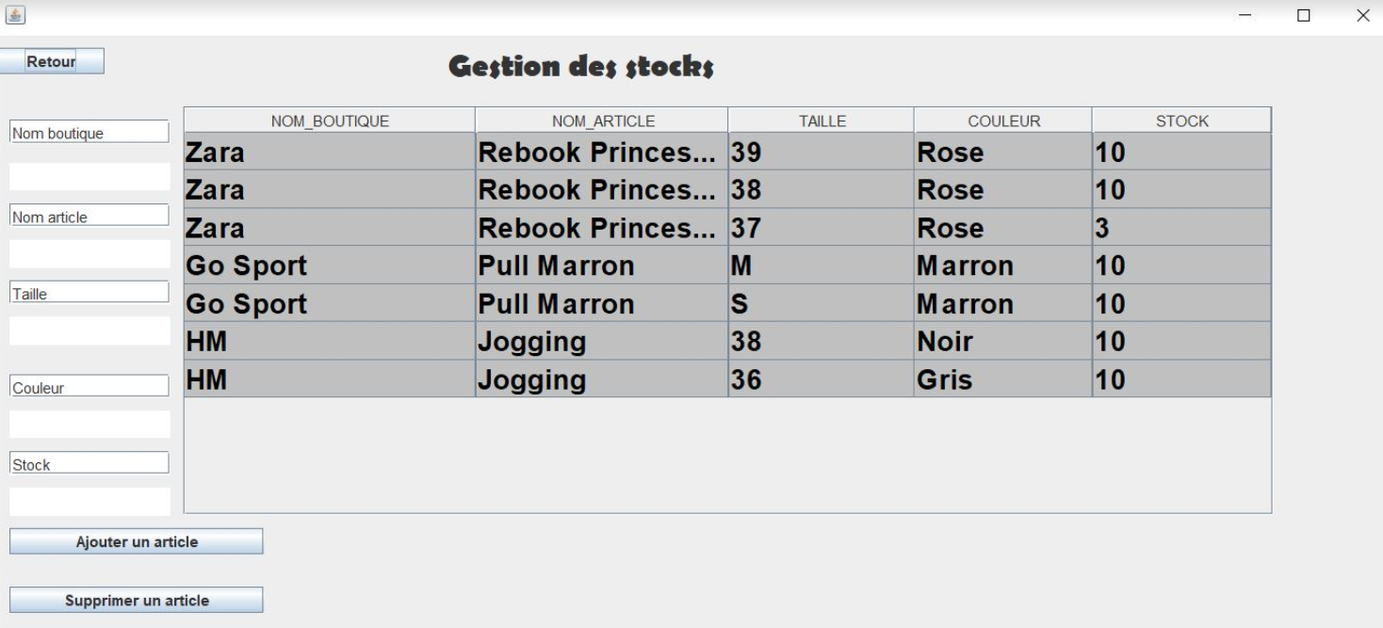

## The Inventory

Information about your actual inventory sorted by shops are accessible via this tab.

As a result, the view updates and lists the article within your inventory for every shops. By clicking on a cell, you can directly modify the data which is selected.

You also can add an article after you specify :

* The name of the shop
* The article’s name
* The size
* The colour
* The quantity

Then, you only have to click on the “ ajouter un article “ button.

You also can do the same action if you want to delete an article and by clicking on the “ supprimer un article “ button.

If you just want to change the quantity, you can click on the cell and change the number in the “stock” column.